|  |  |
| --- | --- |
| P1C1T1#yIS1 | **ARU Peterborough**  **Mobile Games Development** |

To create a very simple “Treasure Chest” using Blender.

**Aim**: To find out how to use the basic tools found within Blender to create a simple “Treasure Chest”

**Objectives:** At the end of the session, you should be able to…

* Understand what we will be trying to make.
* Create a simple cube and resize to the scale we need for the “Treasure Chest”.
* Using the “Loop Cut” tool to set up the structure for the design.
* Setting up the lid and naming the parts.
* Extruding the bands for the body of the chest and creating the inside space.
* Creating the lid.
* Adding extra components like a “lock” and “handles” to the chest.

**Introduction to software:**

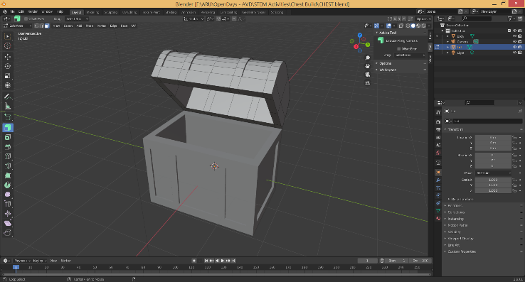

**BLENDER** is a free piece of software used mainly by indie games developer but is starting to be more popular with larger games companies. This software allows you to create simple 3D models used for all types of animations, games and VR experiences.

This can be downloaded at <https://www.blender.org/>

# **Activity 1:**

**Aim:** Understand what we will be trying to make.

For this worksheet we will be looking at creating a very simple, low poly “Treasure Chest”. This will not be 100% accurate, but more cartoon in its style.

The idea of this worksheet it to learn a few of the simple tools available in Blender and see how important it is to think ahead when creating something in 3D.

This “Treasure Chest” will be made up of 3-4 part (depending on if you want to and any handles to your chest). These will be the **BODY** of the chest (the main part), the **LID**, and possibly the **LOCK**.

Around the **BODY** and **LID** will have some **GOLD BANDS** that help add a bit of detail to the design.

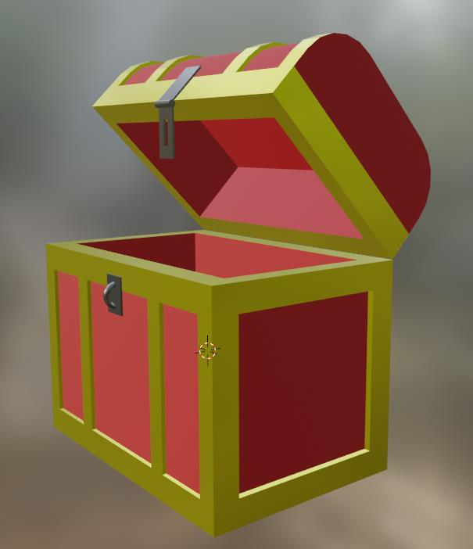

# **Activity 2:**

**Aim:** Create a simple cube and resize to the scale we need for the “Treasure Chest”.

**TASK**:

First, **OPEN BLENDER** by DOUBLE CLICKING on the icon.

Once BLENDER has opened you will be met by this screen…

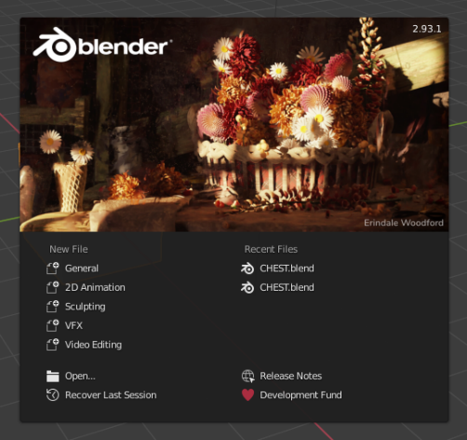

CLICK on “**GENERAL**” from the “**NEW FILE**” list.

You should now see that the software is already displaying a **CUBE** for you in the middle of the development window.

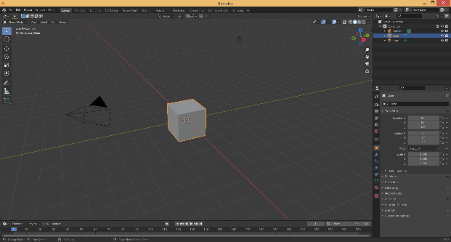

BLENDER is now open ready for you to start to create your “Treasure Chest”. For a new project it will always give you a **CUBE** as a starting shape. But this can be removed by SELECTING it and pressing DELETE on the keyboard. To add a different type of shape you can go to the top of the window and CLICK **ADD** and then **MESH**. Here you will find a few different shapes which you could use.

**TASK**:

For this task we will stick with the **CUBE** that is already on the screen. If you have deleted the **CUBE,** just CLICK **ADD**, then **MESH** and add a new **CUBE.**

Now resize the cube so that it is suitable for the body of the chest. To do this first find/ CLICK on this small arrow (right hand side of the screen), to expand the **TRANSFORM** menu….

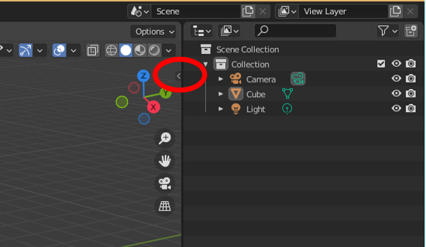

Once you have pressed this small arrow the **TRANSFORM** menu should then appeared, looking like this….

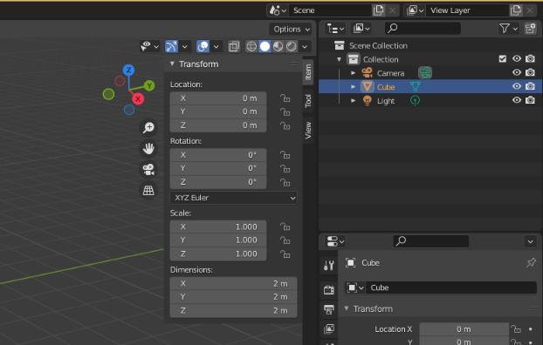

**TASK**:

We can now use this **TRANSFORM** menu to alter the **DIMENSIONS** of the **CUBE** to be suitable for our “**Treasure Chest**”.

CLICK on the **CUBE** to select it, and then in the **TRANSFORM** menu CHANGE the **DIMENSIONS** so that they are….

**X = 2m**

**Y = 3m**

**Z = 2m**

You should now see that the cube has changed shape to match the new dimensions.

This is making a VERY big “**Treasure Chest**” (3 meters wide!!), but for this example we will not worry too much about the scale of the final object.

**TASK**:

Next, we need to change the **VIEW** of screen. Currently we are in **OBJECT** **MODE**, but to make changes to the shape (MESH) we need to change this to **EDIT MODE**.

In the top left-hand corner look for the button labelled **OBJECT** **MODE,** CLICK to open the dropdown list, and select **EDIT MODE**….

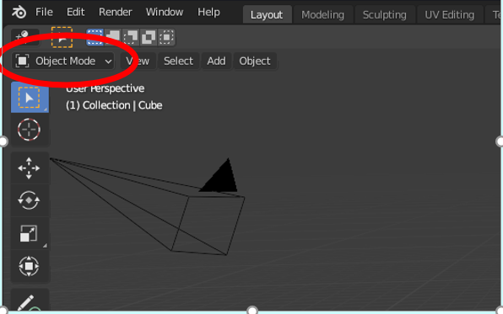

This should now have changed all the options (tools) you have on the left-hand side of the screen.

**TASK**:

You can also at this point, **ZOOM IN** on your **CUBE** using the SCROLL WHEEL on your mouse.

To move around your **CUBE**, you can also CLICK and DRAG the **X, Y, Z** compass in the top righthand corner of the screen.

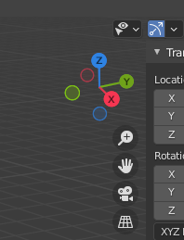

HOLDING DOWN the LEFT MOUSE BUTTON over the **HAND** icon will allow you to **MOVE** the viewpoint around the screen.

Doing the same thing over the **MAGNIFYING GLASS** will be an alternative way to **ZOOM IN AND OUT** of your work.

**ZOOM IN** so the **CUBE** fills the window, and then CLICK on the **X** icon from the compass to show the cube from an angle which will become the front of out “Treasure Chest”. The view should look something like this…

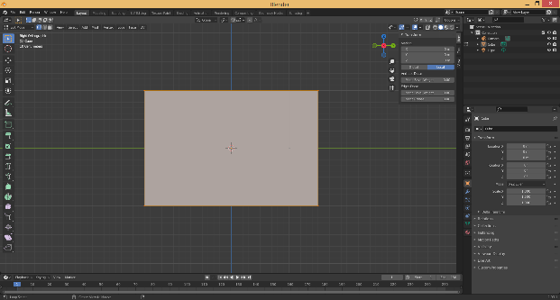

# **Activity 3:**

**Aim:** Using the “Loop Cut” tool to set up the structure for the design.

To give this chest some details, there will be some “banding” that goes around the chest. With this activity we will setup where these bands will appear. To do this we will use something called “**LOOP CUT**”. This is allowing you to break up the cube into sections which we will use to create the details of the chest.

**TASK**:

To use the **LOOP CUT** tool, you need to CLICK on this symbol on the left and side tool list (leaving your mouse cursor over any tool will tell you what it is) ….

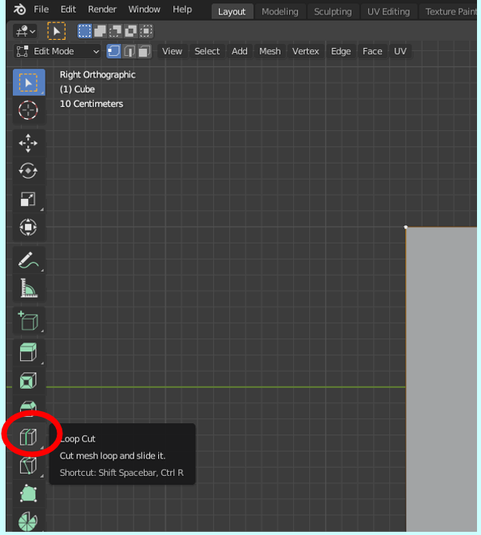

Using this tool, we will effectively “draw in” where all the bands will be that go around the body of the “Treasure Chest.

**TASK**:

The first “**LOOP CUT**” we will make is around the middle of the chest. So, after selecting the **LOOP CUT** tool, MOVE your mouse to the **BOTTOM** of the chest and MOVE the mouse till you have a line appearing **VERTICALLY** across the **MIDDLE** of the chest like this….

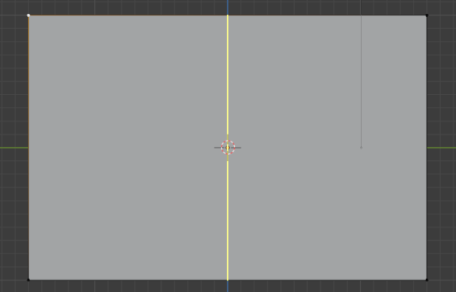

The line will be **YELLOW** until you confirm its position by PRESSING the LEFT MOUSE button. It will then turn **RED**.

If you position this cut in the wrong place just PRESS **UNDO** (CTRL Z on the keyboard).

This is our center line which we will use to measure all the other **LOOP CUT** from.

**TASK**:

This has effectively split this shape into 2. We now need to break it into 4 sections. So, we need to add 2 more **VERTICAL LOOP CUTS** (either side of the center cut).

Repeat the same process as above so your shape looks like this….

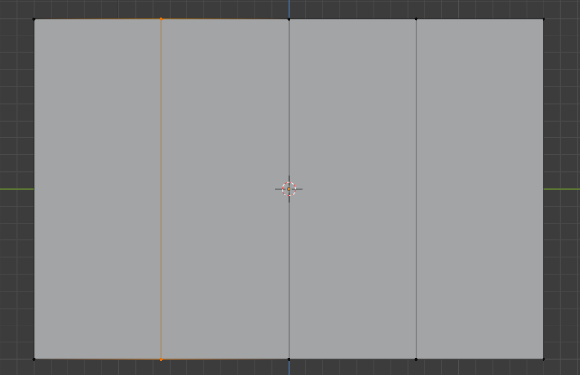

These 3 cuts have split the shape up into 4 sections, which will allow us to place the 4 “vertical bands” around the chest.

**TASK**:

To create the cuts for the “vertical bands” we need 4 more **LOOP CUTS**.

The first will be places in the first of the 4 sections (left hand section).

ADD a **LOOP CUT** so it looks like this (**YELLOW** line in the new **LOOP CUT**) ….

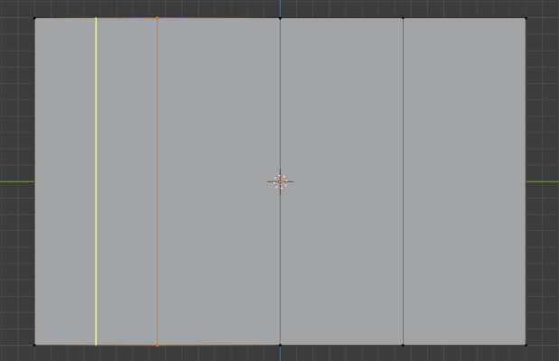

Position this **LOOP CUT** (by PRESSING the **LEFT MOUSE BUTTON**) so that the line turns **RED**.

This **LOOP CUT** is not quiet in the right place, as we do not want the bands to be that big. We need to shrink the width of this cut.

At the bottom of the screen, you should see that there is a small, minimized list….

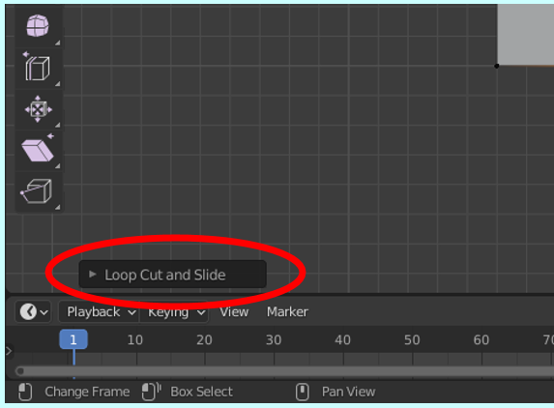

**TASK**:

EXPAND this list so it looks like this….

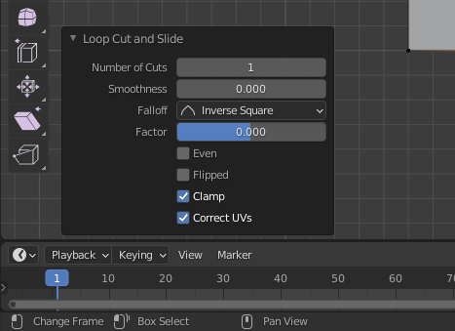

This new menu will allow us to position perfectly where we want this new cut.

CHANGE the value for **FACTOR** to **-0.500**. This should have moved the **LOOP CUT** to more to the left like this….

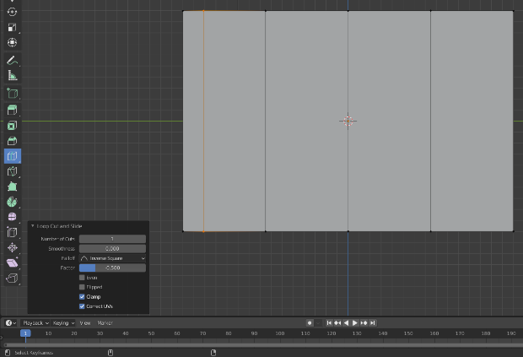

If the line moves the wrong way (more towards the middle, then CHANGE the value for **FACTOR** from **-0.500** to **0.500**)

**TASK**:

We now need to add the other **LOOP CUTS** (one at a time) so yours appears like this….

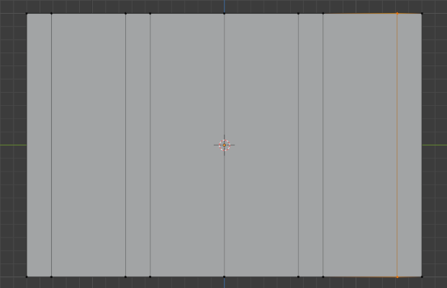

Each **LOOP CUT** has a **FACTOR** or either -**0.500** or **0.500**.

Now for the horizontal bands that go at the top and bottom of the chest. Again, you need a central **LOOP CUT** going across the middle of the chest. Then you need to add a bottom **LOOP CUT** with a **FACTOR** or either -**0.500** (or **0.500**). Then a top is done in the same way….

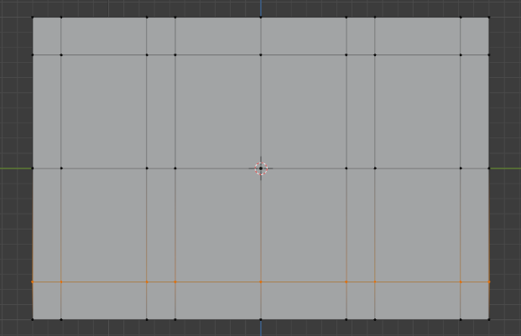

**TASK**:

The next step is to add the **LOOP CUTS** to the shorter sides and top. Luckily by adding the **LOOP CUTS** to the long sides will automatically add them to the top.

On the **X, Y, Z** compass PRESS the **Y** icon to change the viewpoint to the side of the chest.

You should see some of the **LOOP** **CUTS** are already there. These were added when we did the front. Your side view should currently look like this….

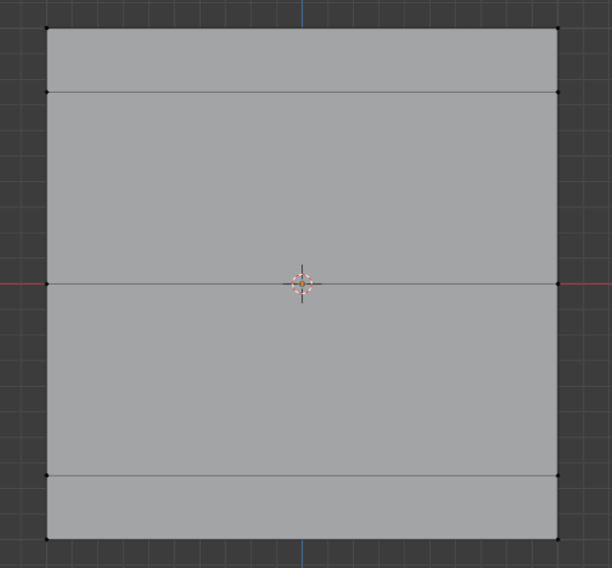

Add some more **LOOP CUTS** so that yours now appears like this (remember the side **LOOP CUTS** should again have a **FACTOR** value should be either -**0.500** or **0.500**) …

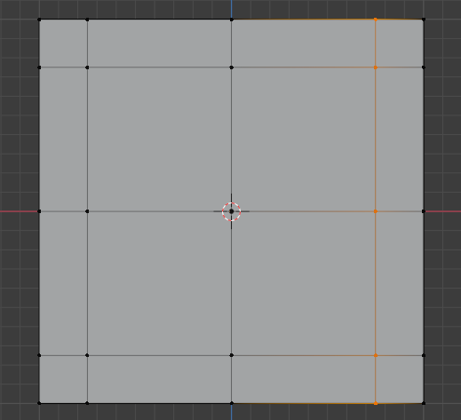

# **Activity 4:**

**Aim:** Setting up the lid and naming the parts.

The **LOOP CUTS** help us setup the design of the chest. But it still does not look like a chest. We have a few more steps before this chest looks like what it should.

Next, we need to start to create the lid for the “treasure chest”. We set this up now as we will want to “copy” some of the **LOOP CUTS** that we have already created. This will save us a lot of time later.

We will start the lid now but will finish the design of it later.

**TASK**:

To start the creation of the lid we are going to **COPY** the top of the chest. To do this, on the **TOOL** list on the left-hand side of the screen, find the **SELECT BOX** tool.

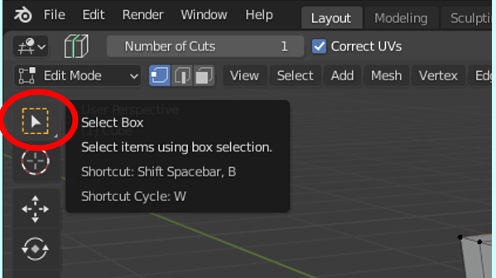

Then change the view (using the **X, Y, Z** compass) so you can see the top of you **CUBE** (top is **Z**).

Now we need to change how we select parts of the **CUBE**. We need to select the **FACES** on the top of the **CUBE** in order to **COPY** them. So, you need to select this icon (**FACE SELECT** one nearest the **VIEW** button) ….

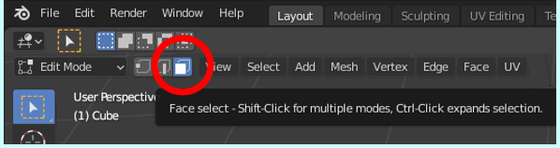

**TASK**:

Now select all the squares/**FACES** from the top of the cube. To do this you can CLICK on each square whiles HOLDING DOWN the **SHIFT** button on the keyboard. Or you can HOLD DOWN the **CTRL** button on the keyboard and CLICK on the corner squares. Pressing **CTRL** will tell the computer to select all **FACES** between the first and last face you clicked on.

You will know when they are all selected when they all turn **ORANGE**.

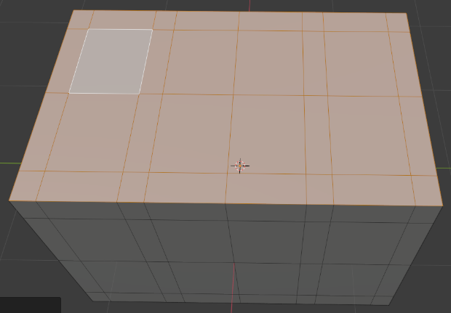

Make sure that only the **FACES** on the top of the **CUBE** have been selected. If you have accidently selected a **FACE** that you did not mean to select, then whiles HOLD DOWN the **SHIFT** button CLICK on that **FACE** again to **DESELECT**.

Once they are all selected go to the top of the screen, LEFT CLICK the button for **MESH**, and from the new dropdown list SELECT **DUPLICATE**.

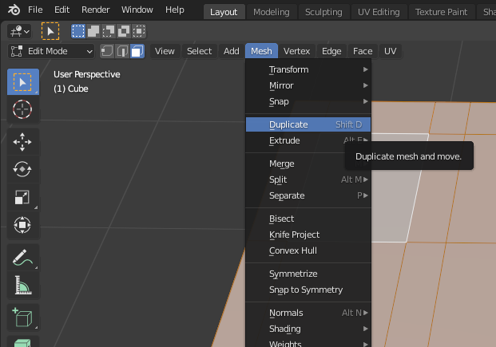

**TASK**:

When you now move your mouse around the screen you will notice that you have a copy of the **FACES** you selected connected to your mouse pointer.

By PRESSING the **RIGHT MOUSE BUTTON w**ill place the copy of your top **FACES** to your screen. This would have placed it directly on top of your original **CUBE**, so you will not see it.

Now RIGHT CLICK on your **CUBE**, and from the popup menu SELECT **SEPARATE** and then **SELECTION**.

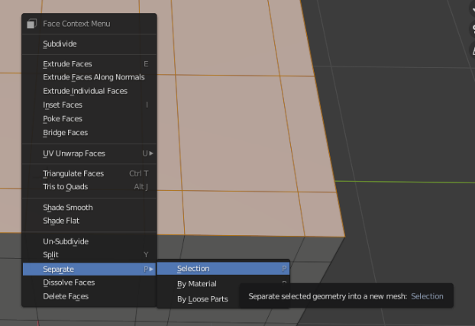

This has placed the new copy of the top of your **CUBE** as a new **OBJECT**. You can tell this by looking over to the right-hand side of the screen in the **SCENE COLLECTION** list….

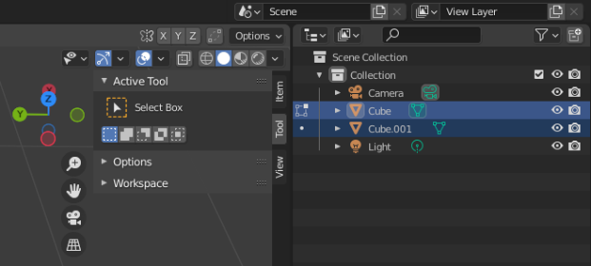

You should see you have 2 **CUBES** listed (“Cube” and “Cube001”). One is the original object and the other is the new **DUPLICATE** top. You can check which one is which by CLICKING on the **EYE** icon. This will hide the **OBJECT** it belongs too. The new **CUBE** is a **FLAT PLAN**.

**TASK**:

The new **DUPLICATE** top is going to be the start of our lid. So, within the **SCENE COLLECTION** DOUBLE CLICK on the word “**Cube001**” and RENAME this “**Lid**” (as this should be the lid).

Now do the same with “**Cube**” and RENAME this “**Body**” (as this should be the body of the chest).

If these are the wrong way round, then rename them accordingly.

Then HIDE the **LID** (CLICKING on the **EYE** icon) as we will be dealing with this later.

# **Activity 5:**

**Aim:** Extruding the bands for the body of the chest and creating the inside space.

We have now completed all the setting up of the chest. But this still does not look like a “Treasure Chest”. Now is when we start to make it look more like a chest.

To do this we will use the “**EXTRUDE**” tool. To “**EXTRUDE**” means to push or pull a surface from its original position. We will use the “**EXTRUDE**” tool to slightly push back some parts of the chest in order for the bands to stand out.

**TASK**:

First to select the right “**EXTRUDE**” tool (as there are more than one). The one we need to use is the “**EXTRUDE ALONG** **NORMALS**”. To select this, you need to CLICK and HOLD DOWN the **LEFT MOUSE BUTTON** over the **EXTRUDE** tool button (found on the left-hand side tool list). This will bring up a sub menu where you can then SELECT the required **EXTRUDE ALONG NORMALS** tool….

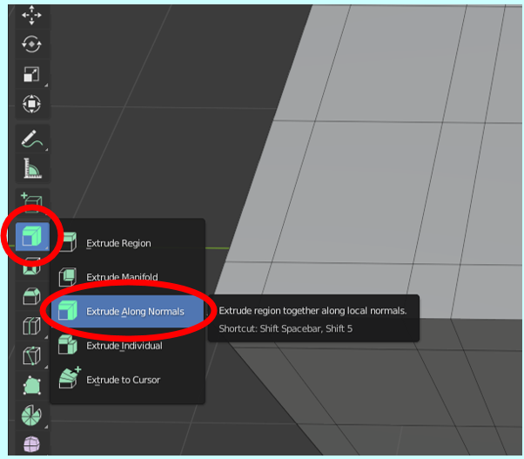

**TASK**:

Now we have the right tool selected, we need to select the **FACES** we want to “**EXTRUDE**”.

ROTATE the **CUBE** so that you are looking at one of the longer sides (**X** on the **X, Y, Z** compass).

SELECT the **FACES** that are not going to represent the bands. To select all the required **FACES,** you need to HOLD DOWN the **SHIFT** key on the keyboard as you CLICK the **LEFT-HAND MOUSE BUTTON** on each **FACE**. Your selection should look like this….

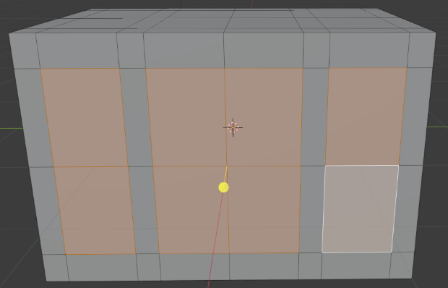

ROTATE the **CUBE** and SELECT the same faces, whiles still HOLDING DOWN the **SHIFT** key, from the other side.

Then ROTATE the **CUBE** so that you see one of the short sides (**Y** on the **X, Y, Z** compass), and SELECT the center 4 FACES, whiles still HOLDING DOWN the **SHIFT** key, like this….

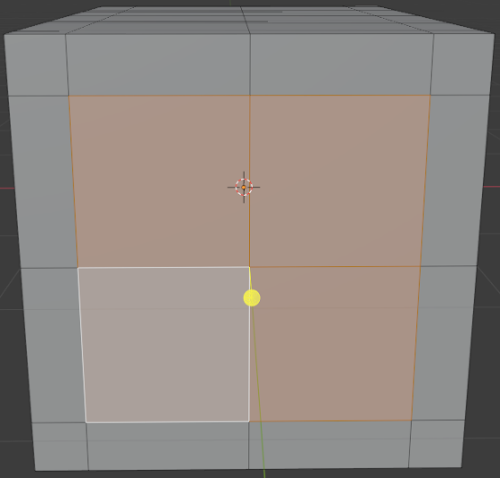

Then do the same with the final side of the **CUBE**. Now you should have faces selected on all 4 sides of the chest. RELEASE the **SHIFT** button once you have selected all required sides.

**TASK**:

Now we need to **EXTRUDE** the **FACES**. We will be moving the selected **FACES** inwards to make the bands stand out.

We have selected **FACES** from all side so we can adjust them all at the same time to the same distance.

To use the **EXTRUDE** tools you just need to CLICK AND HOLD the **LEFT MOUSE BUTTON** over the **YELLOW DOT WITH A LINE DOWN BELOW IT**. Now DRAG the mouse **DOWNWARDS** slightly so that you can see the **FACES** move inwards.

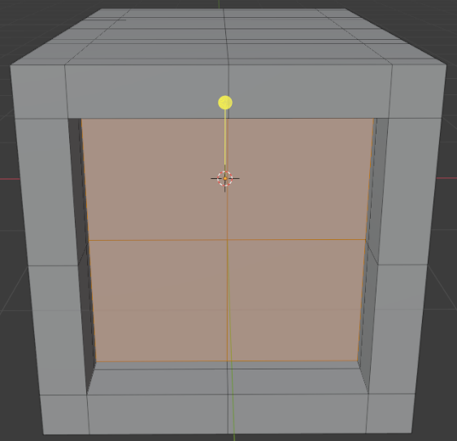

**TASK**:

Before you do anything else we need to make sure we have **EXTRUDED** the faces to the right depth. After you RELEASED the **LEFT MOUSE BUTTON** you will have noticed a new popup menu appear at the bottom left of the screen that looks like this….

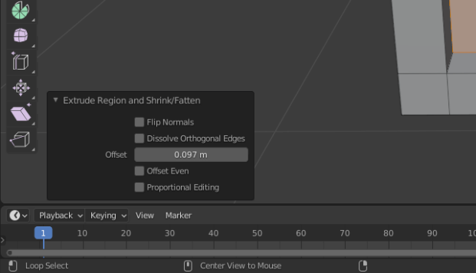

We only need the **FACES** to be slightly **EXTRUDED**. So, we need to CHANGE the **OFFSET** value to **-0.04**. We need to remember this value so we can use the same for the lid. But if you think this is not enough/too much you can alter this value to what you want.

It should now look like this….

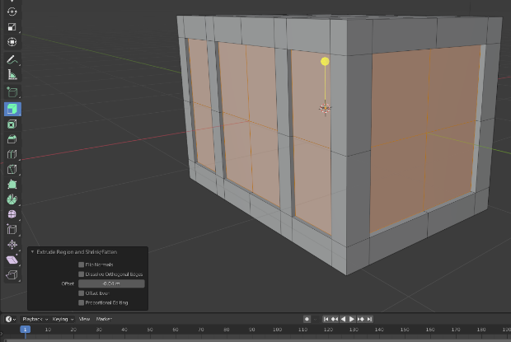

If you rotate your “body” **CUBE**, you should notice all sides have had **FACES EXTRUDED**. If they haven’t then you need to **EXTRUDE** these sides separately. Any mistakes can be changed by **UNDOING** (PRESSING CTRL **Z**).

**TASK**:

Now to make this chest hollow, so objects could be placed within it. To do this we will **EXTRUDE** the top of the **CUBE**.

ROTATE the **CUBE** so that you can see the top (**Z** on the **X, Y, Z** compass).

Now, like you did for the sides, SELECT the center **FACES** using the **SHIFT** key and **LEFT MOUSE BUTTON**….

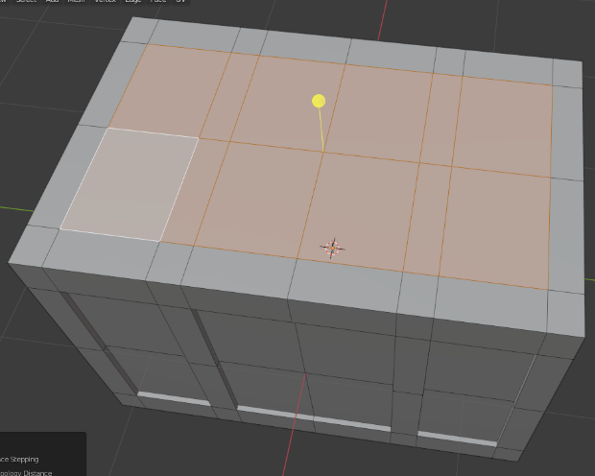

CLICK AND DRAG down the **YELLOW DOT DOWNWARDS**.

You could move this down by eye if you chose, or you can ALTER the **OFFSET** value in the **EXTRUDE** popup menu to be around a maximum of **1.6** (Remember the chest is only 2 high) ….

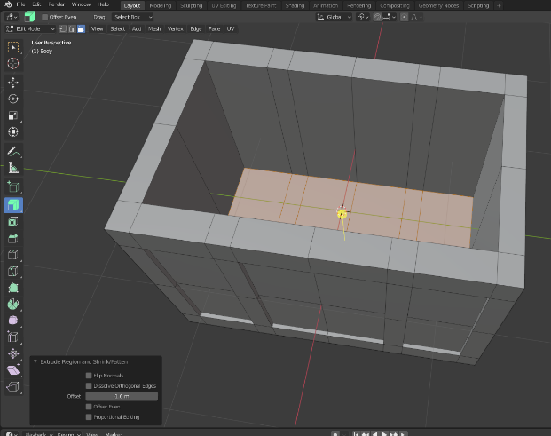

# **Activity 6:**

**Aim:** Creating the lid.

We now have the basics for the body of the chest, next is to concentrate on the lid.

**TASK**:

First, we need to **UNHIDE** the **LID** object. So, CLICK on the **EYE** image next to the **LID** title in the **SCENE COLLECTION** (Top right-hand corner of the screen). Then **HIDE** the **BODY**.

SELECT the **LID** object in the **SCENE COLLECTION** (by CLICKING on it). Then make sure that the **MODE** is set to **EDIT MODE** (top left-hand corner of screen).

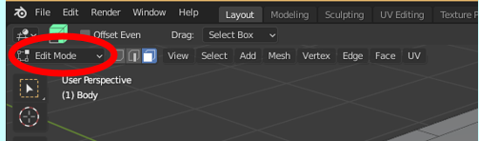

Go back to the **SCENE COLLECTION** and CLICK on the **DOT** next to the **LID** title (highlighted below). The **DOT** shows this is not the object being edited. By CLICKING on it, it will show a **SQUARE** looking symbol (which shows this is the current object).

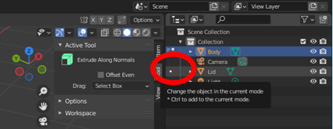

The **LID** should now appear to show the different **FACES**.

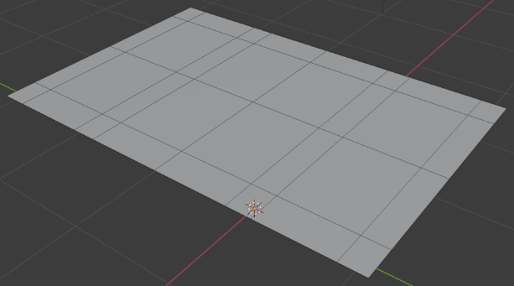

**TASK**:

Now to make this to the correct height (as currently it is a flat plan).

PRESS **A** on the keyboard to select all the **FACES** (the **LID** should now look **ORANGE**).

SELECT the **EXTRUDE** tool from the tools list (as we did for the **BODY** of the chest)

Then CLICK AND DRAG the **YELLOW DOT**, that appeared above the **LID** plane, **UPWARDS** to give it some thickness.

Finally, we need to set the thickness of the **LID** to the correct value. You can do this again by looking at the new popup list that has appeared at the bottom left-hand corner of the screen.

Set the **VALUE** for **OFFSET** to **1m** (which is half the height of the **BODY**). But you can make this slightly bigger or smaller is you choose. To check the height, you can always **UNHIDE** the **BODY** and compare the sizes.

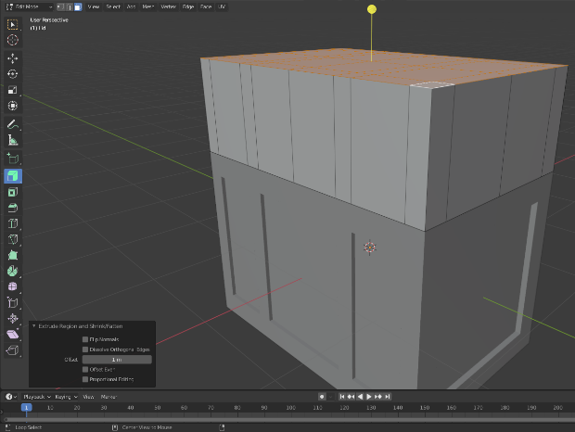

**TASK**:

Next to add the **BAND** that goes around the base of the **LID** (where it opens). Again, to do this we need to use the **LOOP CUT** tool (SELECTED from the tool list).

The **LOOP CUT** should have a **FACTOR** of **0.500** (like we did for the **BANDS** on the **BODY**). If the **LOOP CUT** appears closer to the top of the **LID**, CHANGE the **FACTOR** to -**0.500.**

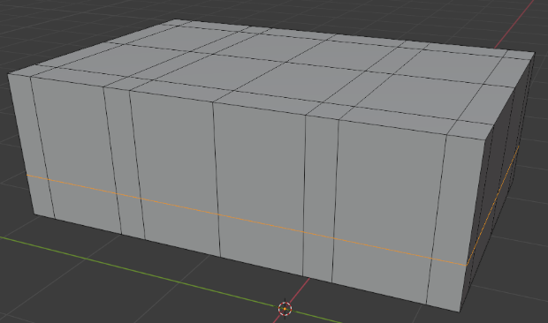

**TASK**:

Now to **CURVE** the **LID** by rounding off the edges. But to do this we need to do some cleaning up of the **FACES**. We currently have too many which will not allow the **LID** to **CURVE** correctly. So, we need to **DISSOLVE** the **EDGES** to merge the **FACES** we don’t need.

CHANGE the tool so we are using the **SELECT BOX** selected.

Then CHANGE the viewpoint to **Y** (on the **X, Y, Z** compass)

Now, whiles HOLDING DOWN the **SHIFT** key, SELECT the outer **EDGES** (the ones highlighted below) ….

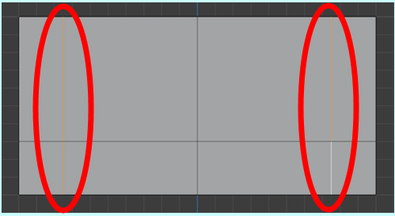

Once they are selected, RIGHT CLICK on the mouse to load up the **OPTIONS MENU**.

From this menu you need to **SELECT DISSOLVE EDGES**….

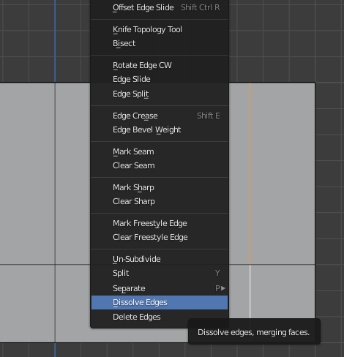

By doing this you should have noticed that the highlighted **EDGES** have now disappeared.

**TASK**:

Do the same, as before, with the other short side and the top of the **LID**.

DO NOT do this to the same lines on the bottom of the **LID** or the long sides.

**TASK**:

Now we just need to **BEVEL** the top to make it appear **CURVED**.

SELECT, from the tool list, the **BEVEL** tool.

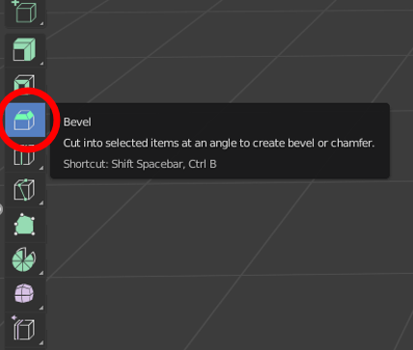

Back to the **LID**, you need to SELECT the 2 corner **EDGES** (as shown below) ….

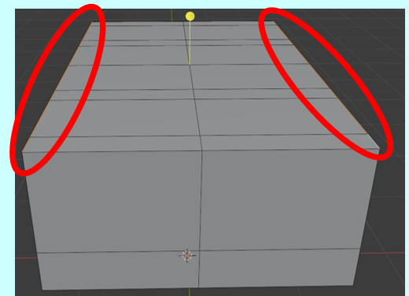

**TASK**:

Again, a **YELLOW DOT** should have appeared above your lid. CLICK AND DRAG that either **UPWARDS** or **DOWNWARDS** until the sides of the **LID** start to change.

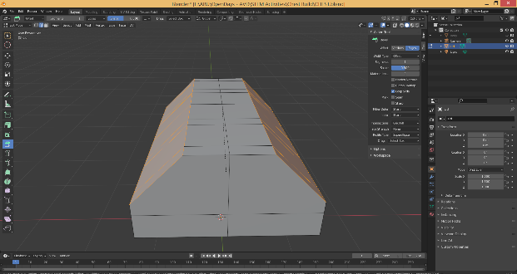

Like before a new popup menu that has appeared in the bottom left-hand corner. This will allow you to alter the appearance of the **BEVEL**.

WITHIN this new **BEVEL** popup menu CHANGE the following….

**WIDTH = 0.85m**

**SEGMENTS = 5**

**SHAPE = 0.500**

Although you can make your own choice to what these values should be if you choose.

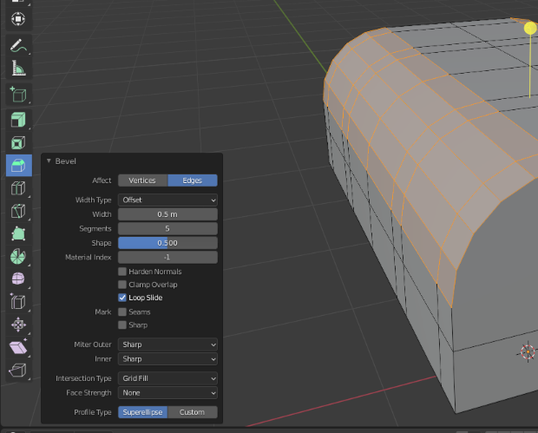

**TASK**:

Next, like the **BASE**, we need to make the **BANDS** standout by using the **EXTRUDE** tool.

Change the **SELCTION** options from **EDGE SELECT** to **FACE SELECT**. This can be found at the top left-hand corner of the screen (see below) ….

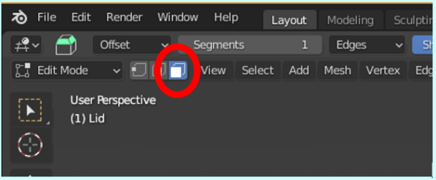

From the tools list SELECT the **EXTRUDE** tool.

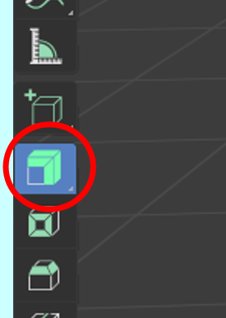

Now SELECT (whiles HOLDING DOWN the **SHIFT** key) all the **FACES** that are not going to be the **BANDS**.

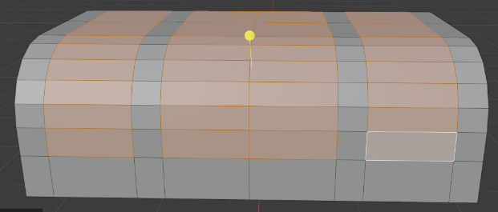

**TASK**:

Then (like before) CLICK AND DRAG the **YELLOW DOT DOWNWARDS** to start to move the selected faces **INWARDS**.

Then to set this indentation to be the same as the body. In the popup menu CHANGE the **OFFSET** to **-0.04**.

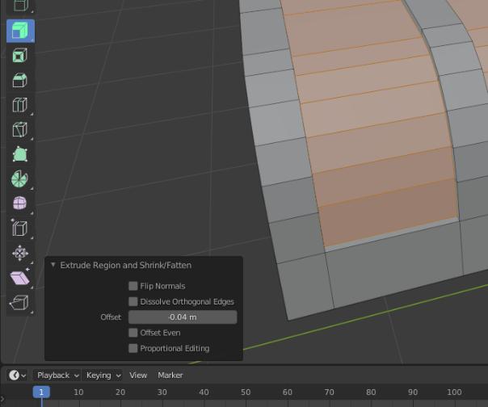

You can then **UNHIDE** the **BODY** and see the overall “Treasure Chest” looks.

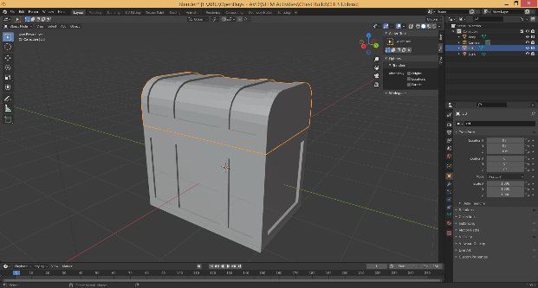

The “Treasure Chest” is starting to look like what it is mean to be. But to make it look more interesting maybe we could have the lid of the chest open.

**TASK**:

To have the chest open we will need to **ROTATE** the **LID** and then reposition it correctly.

Make sure in the **SCENE COLLECTION** you have SELECTED the **LID**, and that it shows that this object is the one being able to be **EDITED** (show a **SQUARE** looking symbol beside the title).

Now PRESS **A** on the keyboard to select the whole **LID**. It should all be now **ORANGE**.

Then from the tool list SELECT the icon for **ROTATE**.

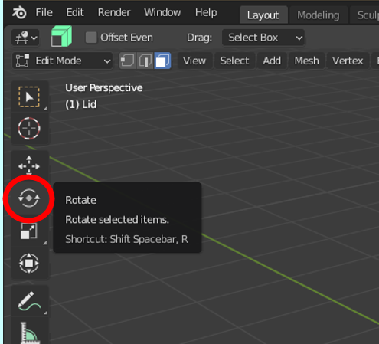

Once this has been selected you should see the following image appear above the **LID**….

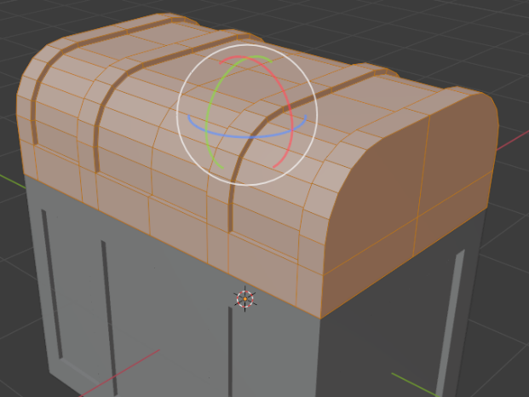

**TASK**:

If you CLICK AND DRAG the **GREEN** **CIRCLE** to the **RIGHT,** you will be able to **ROTATE** the **LID** so that it appears to be open.

You will also see a new popup menu appear in the bottom of the screen. Within this menu you could set the **ANGLE** to **-45.**

**TASK**:

The **LID** will not be in the correct place as the rotation happened from the center of the **LID**.

Find the **MOVE** tool from the tool list and move the **LID** into the correct position. You might want to CHANGE the viewpoint to **Y** on the **X, Y, Z** compass. This viewpoint will make it easier to position the **LID** correctly.

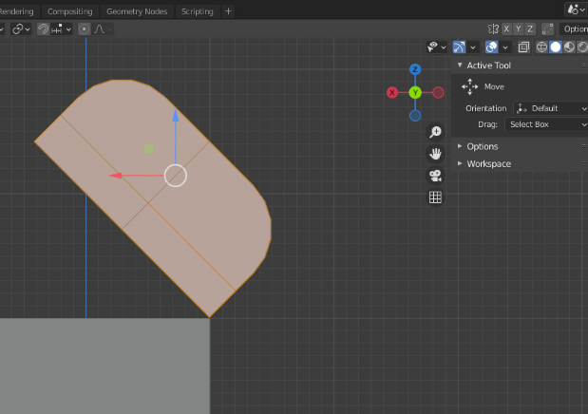

**TASK**:

When you rotate the view (moving the **X, Y, Z** compass) you will notice that the lid requires the insides to be **EXTRUDED,** as it currently looks like this….

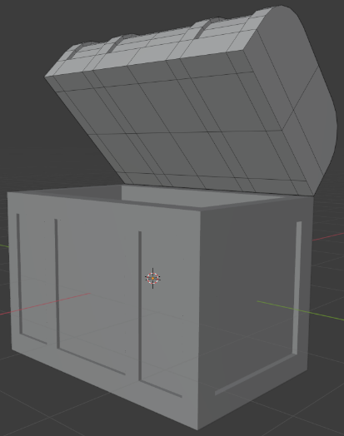

Like we did for the **BASE** we need to **EXTRUDE** the middle **FACES,** so it makes the **LID** appear “hollow”, like the following...

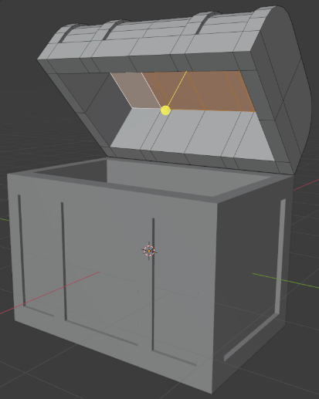

The **OFFSET** I used for my example was **-0.8** (as the **LID** is only 1m thick), but you can use your own value to what looks correct.

# **Activity 7:**

**Aim:** Adding extra components like a “lock” and “handles” to the chest.

A “treasure chest” would normally have handles and a lock. To do this you could use the same tools we have used so far.

**TASK**:

To start to create additional items to make it look more like a chest, you will need to add a new **MESH** to the model.

To do this you need to go to the top of the screen and CLICK on **ADD**. Then from the new dropdown list select a shape that matches what you are intending to add.

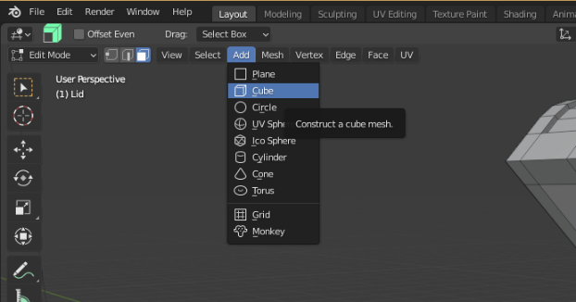

When the new shape appears on the screen you will need to make it a separate object in the **SCENE COLLECTION**. To do this RIGHT CLICK your mouse to bring up new menu list, MOVE YOUR MOUSE over **SEPARATE** and then CLICK on **SELECTION**.

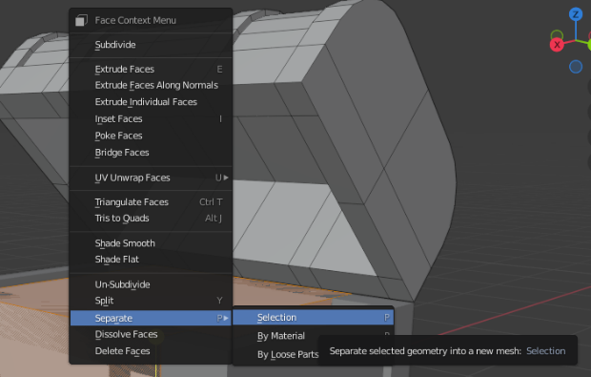

You should now have this new **OBJECT** as a new item in the **SCENE COLLECTION**, which needs renaming.

**TASK**:

Now using your knowledge so far of the software, and some experimentation, try to make either a lock or handles for your “treasure chest”.

